LAB 01 REPORT  
OBJECT-ORIENTED PROGRAMMING

# The Very First Java Programs

## *2.2.1* Write, compile the first Java application:

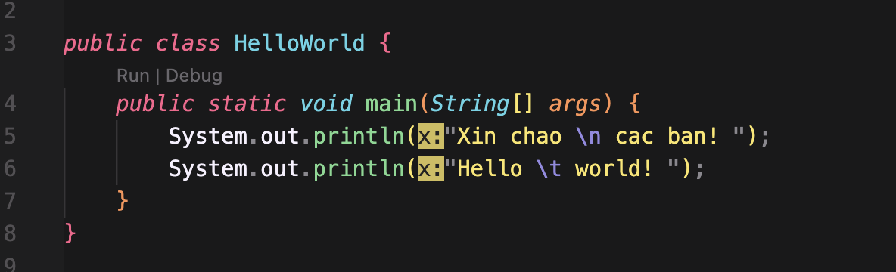

*Result*

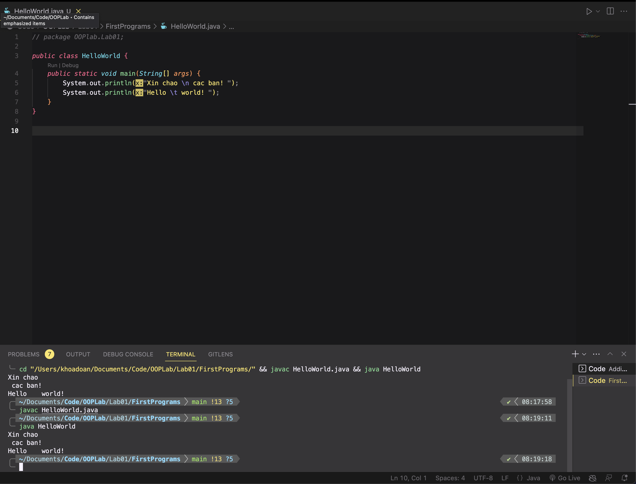

## 2.2.2 Write, compile the first dialog Java program

### 

### 

## 2.2.3 Write, compile the first input dialog Java application

## 

## 

## 2.2.4 Write, compile, and run the following example:

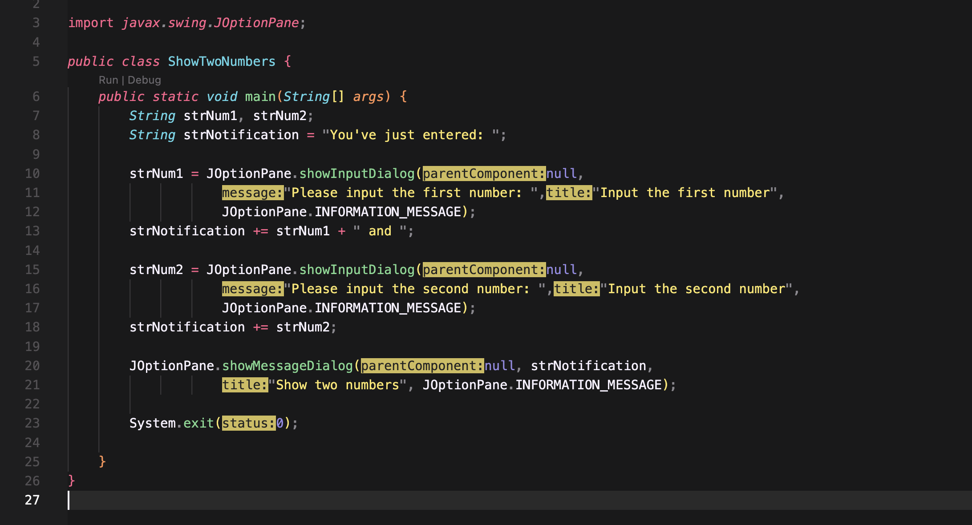

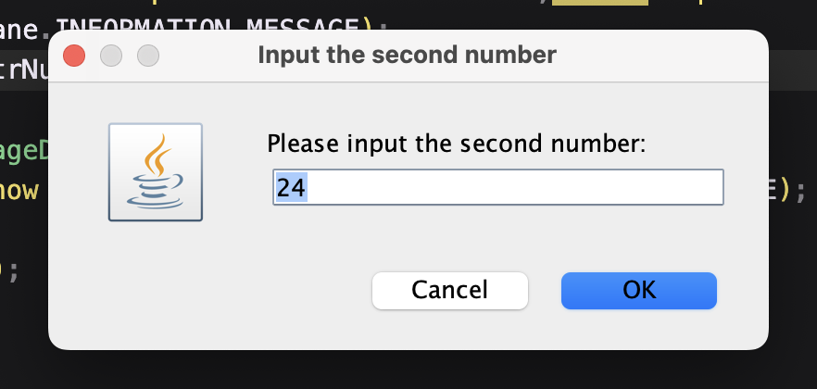

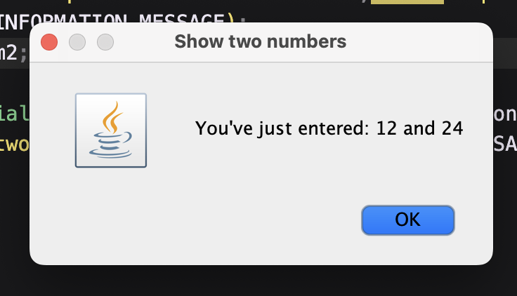

## 2.2.5 Write a program to calculate sum, difference, product, and quotient of 2 double numbers which are entered by users.

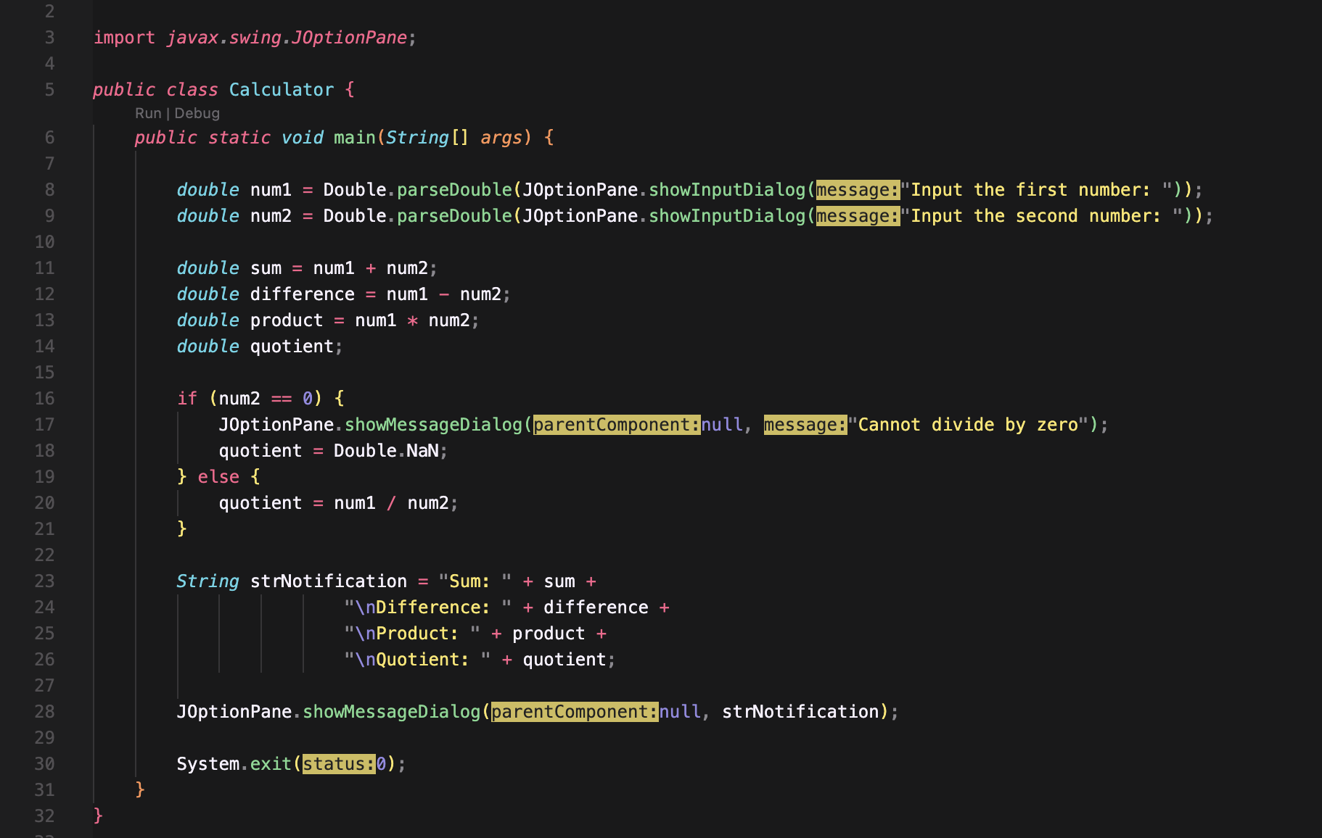

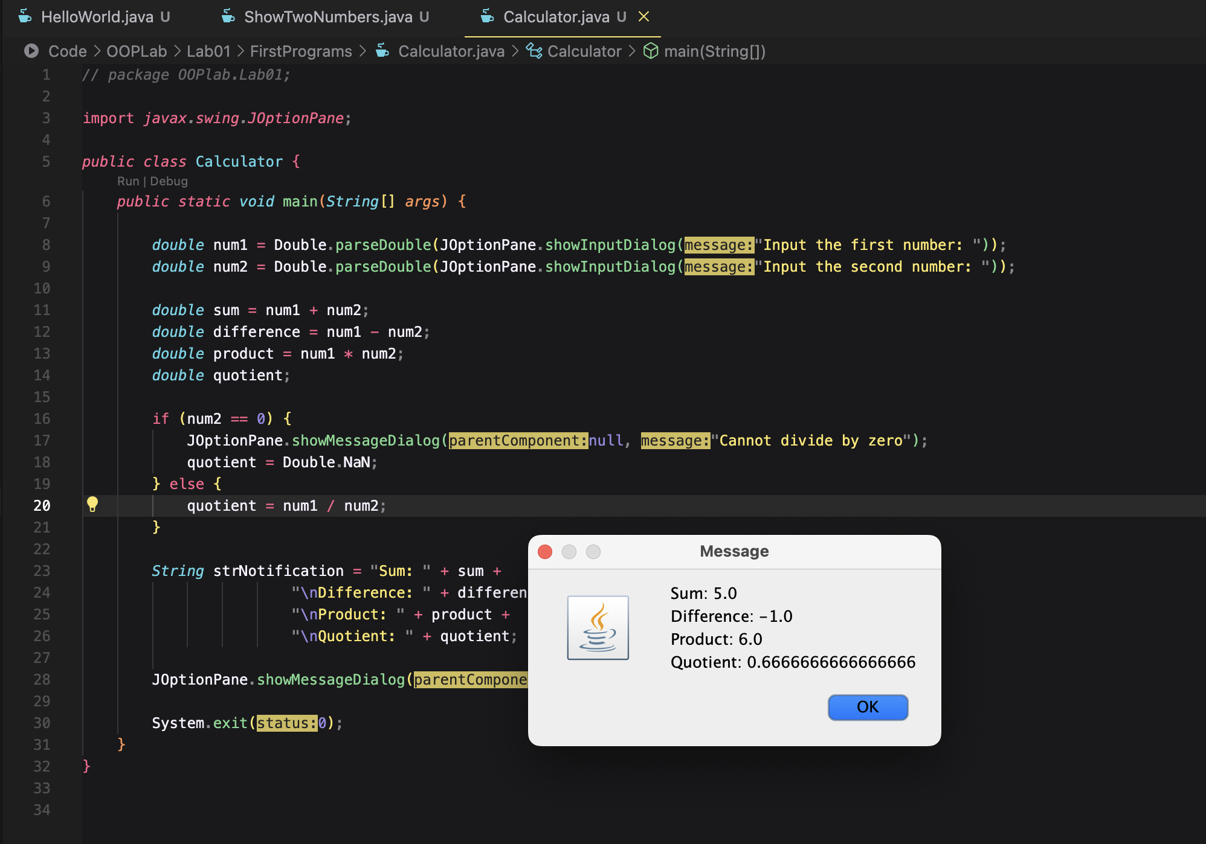

2.2.6 Write a program to solve:

For simplicity, we only consider the real roots of the equations in this task.

- The first-degree equation (linear equation) with one variable

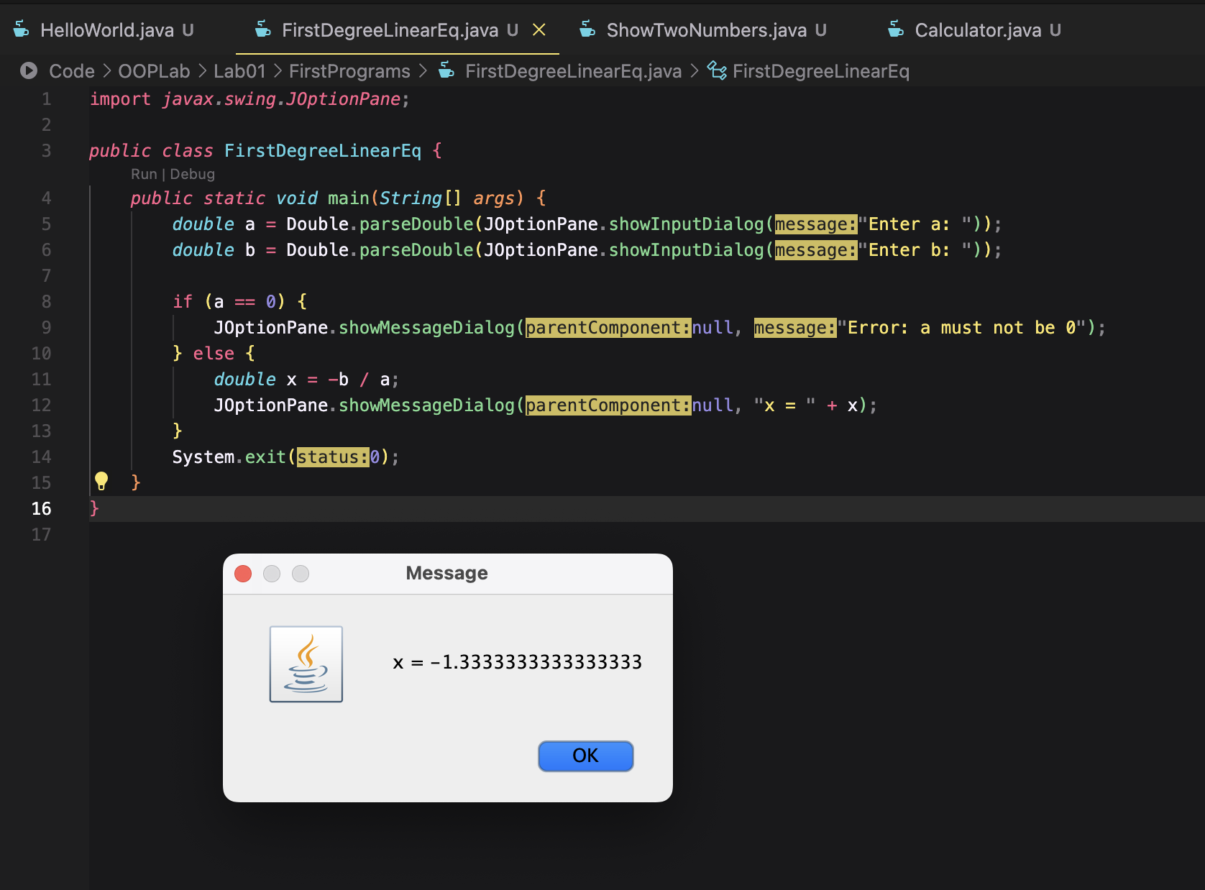

- The system of first-degree equations (linear system) with two variables

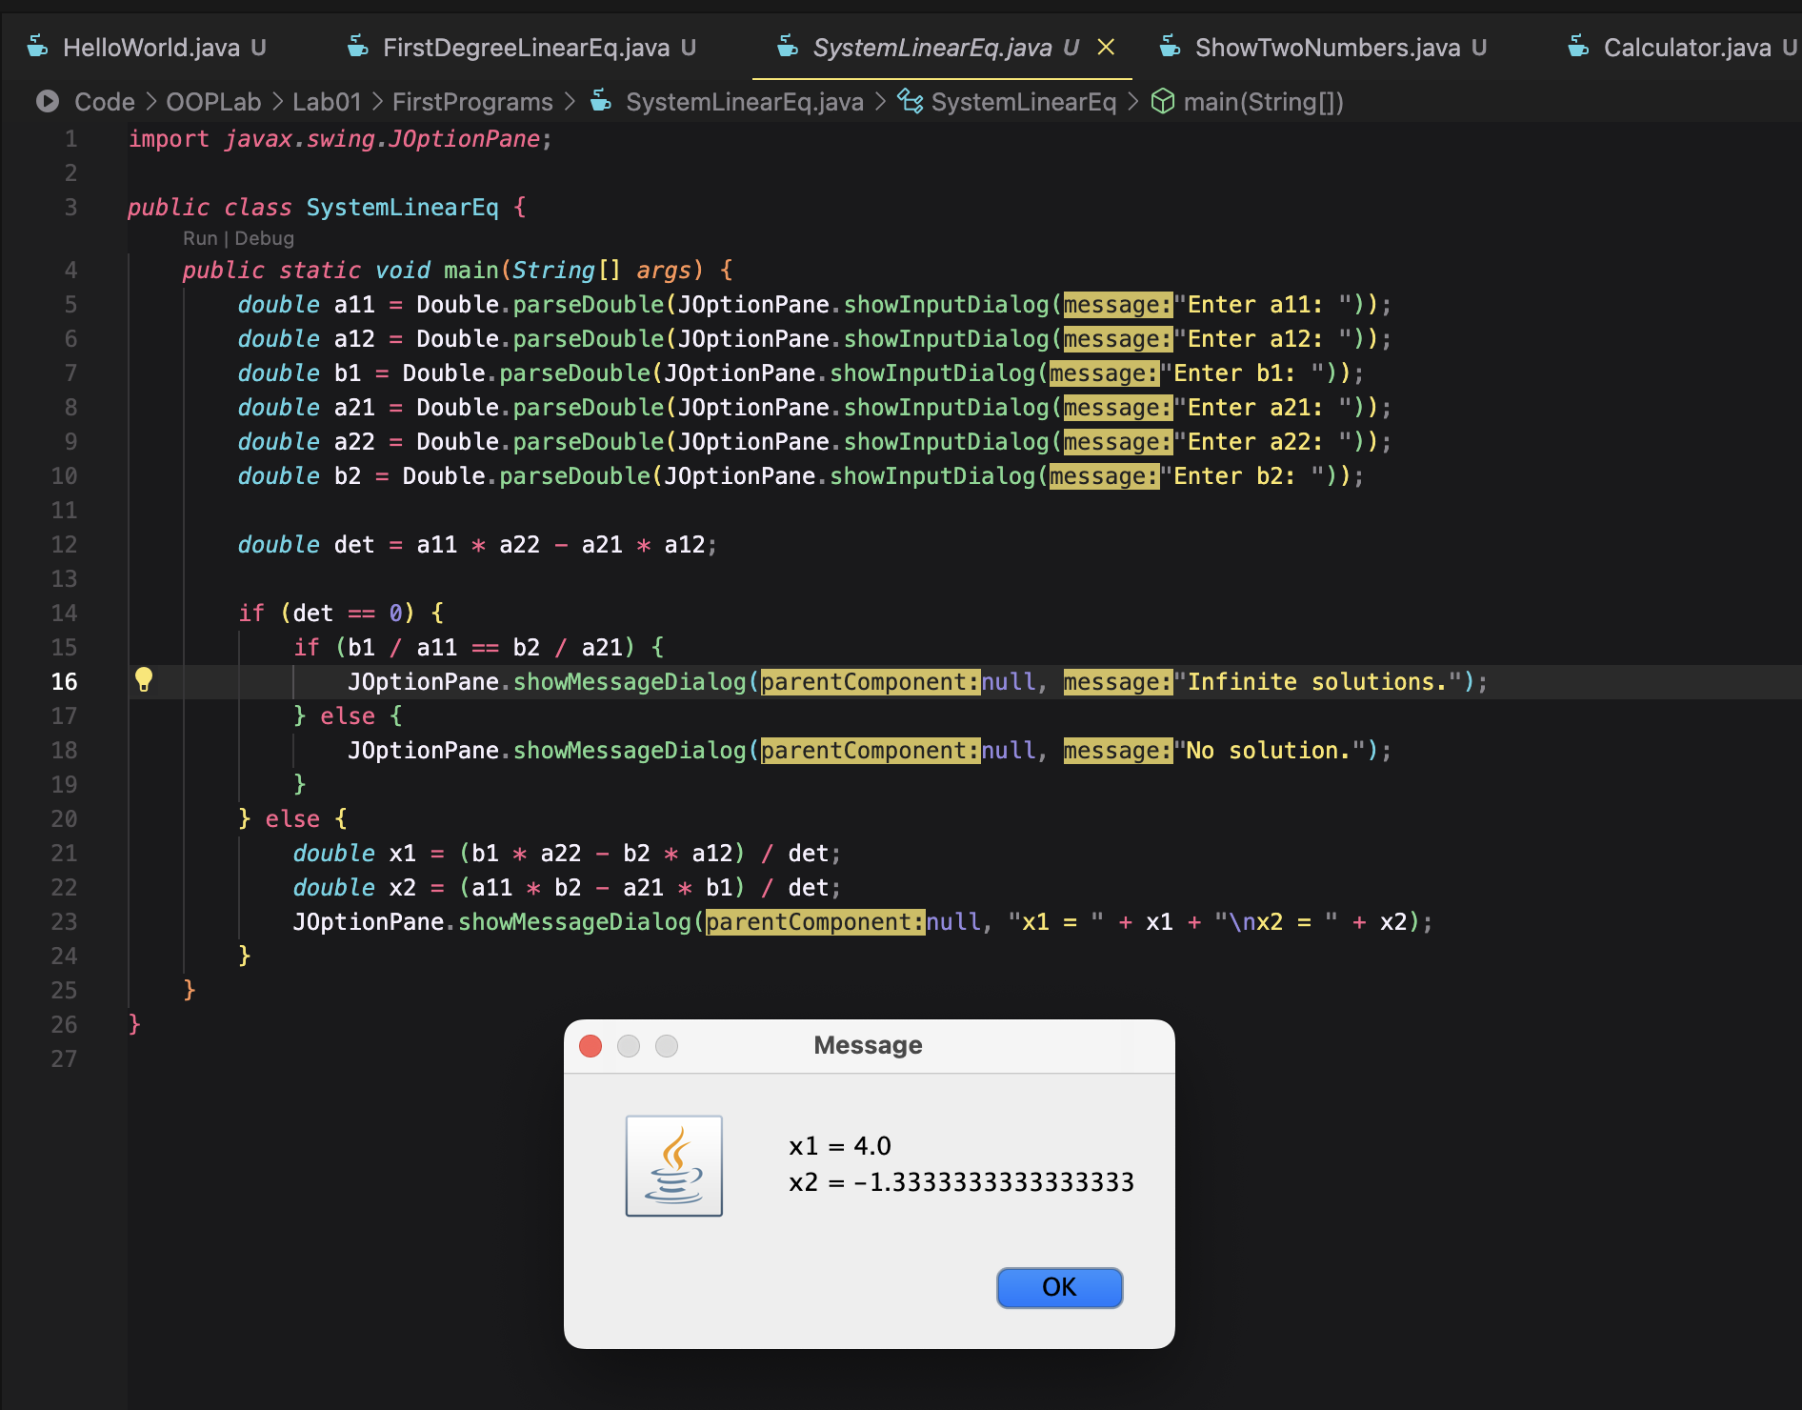

- The second-degree equation with one variable

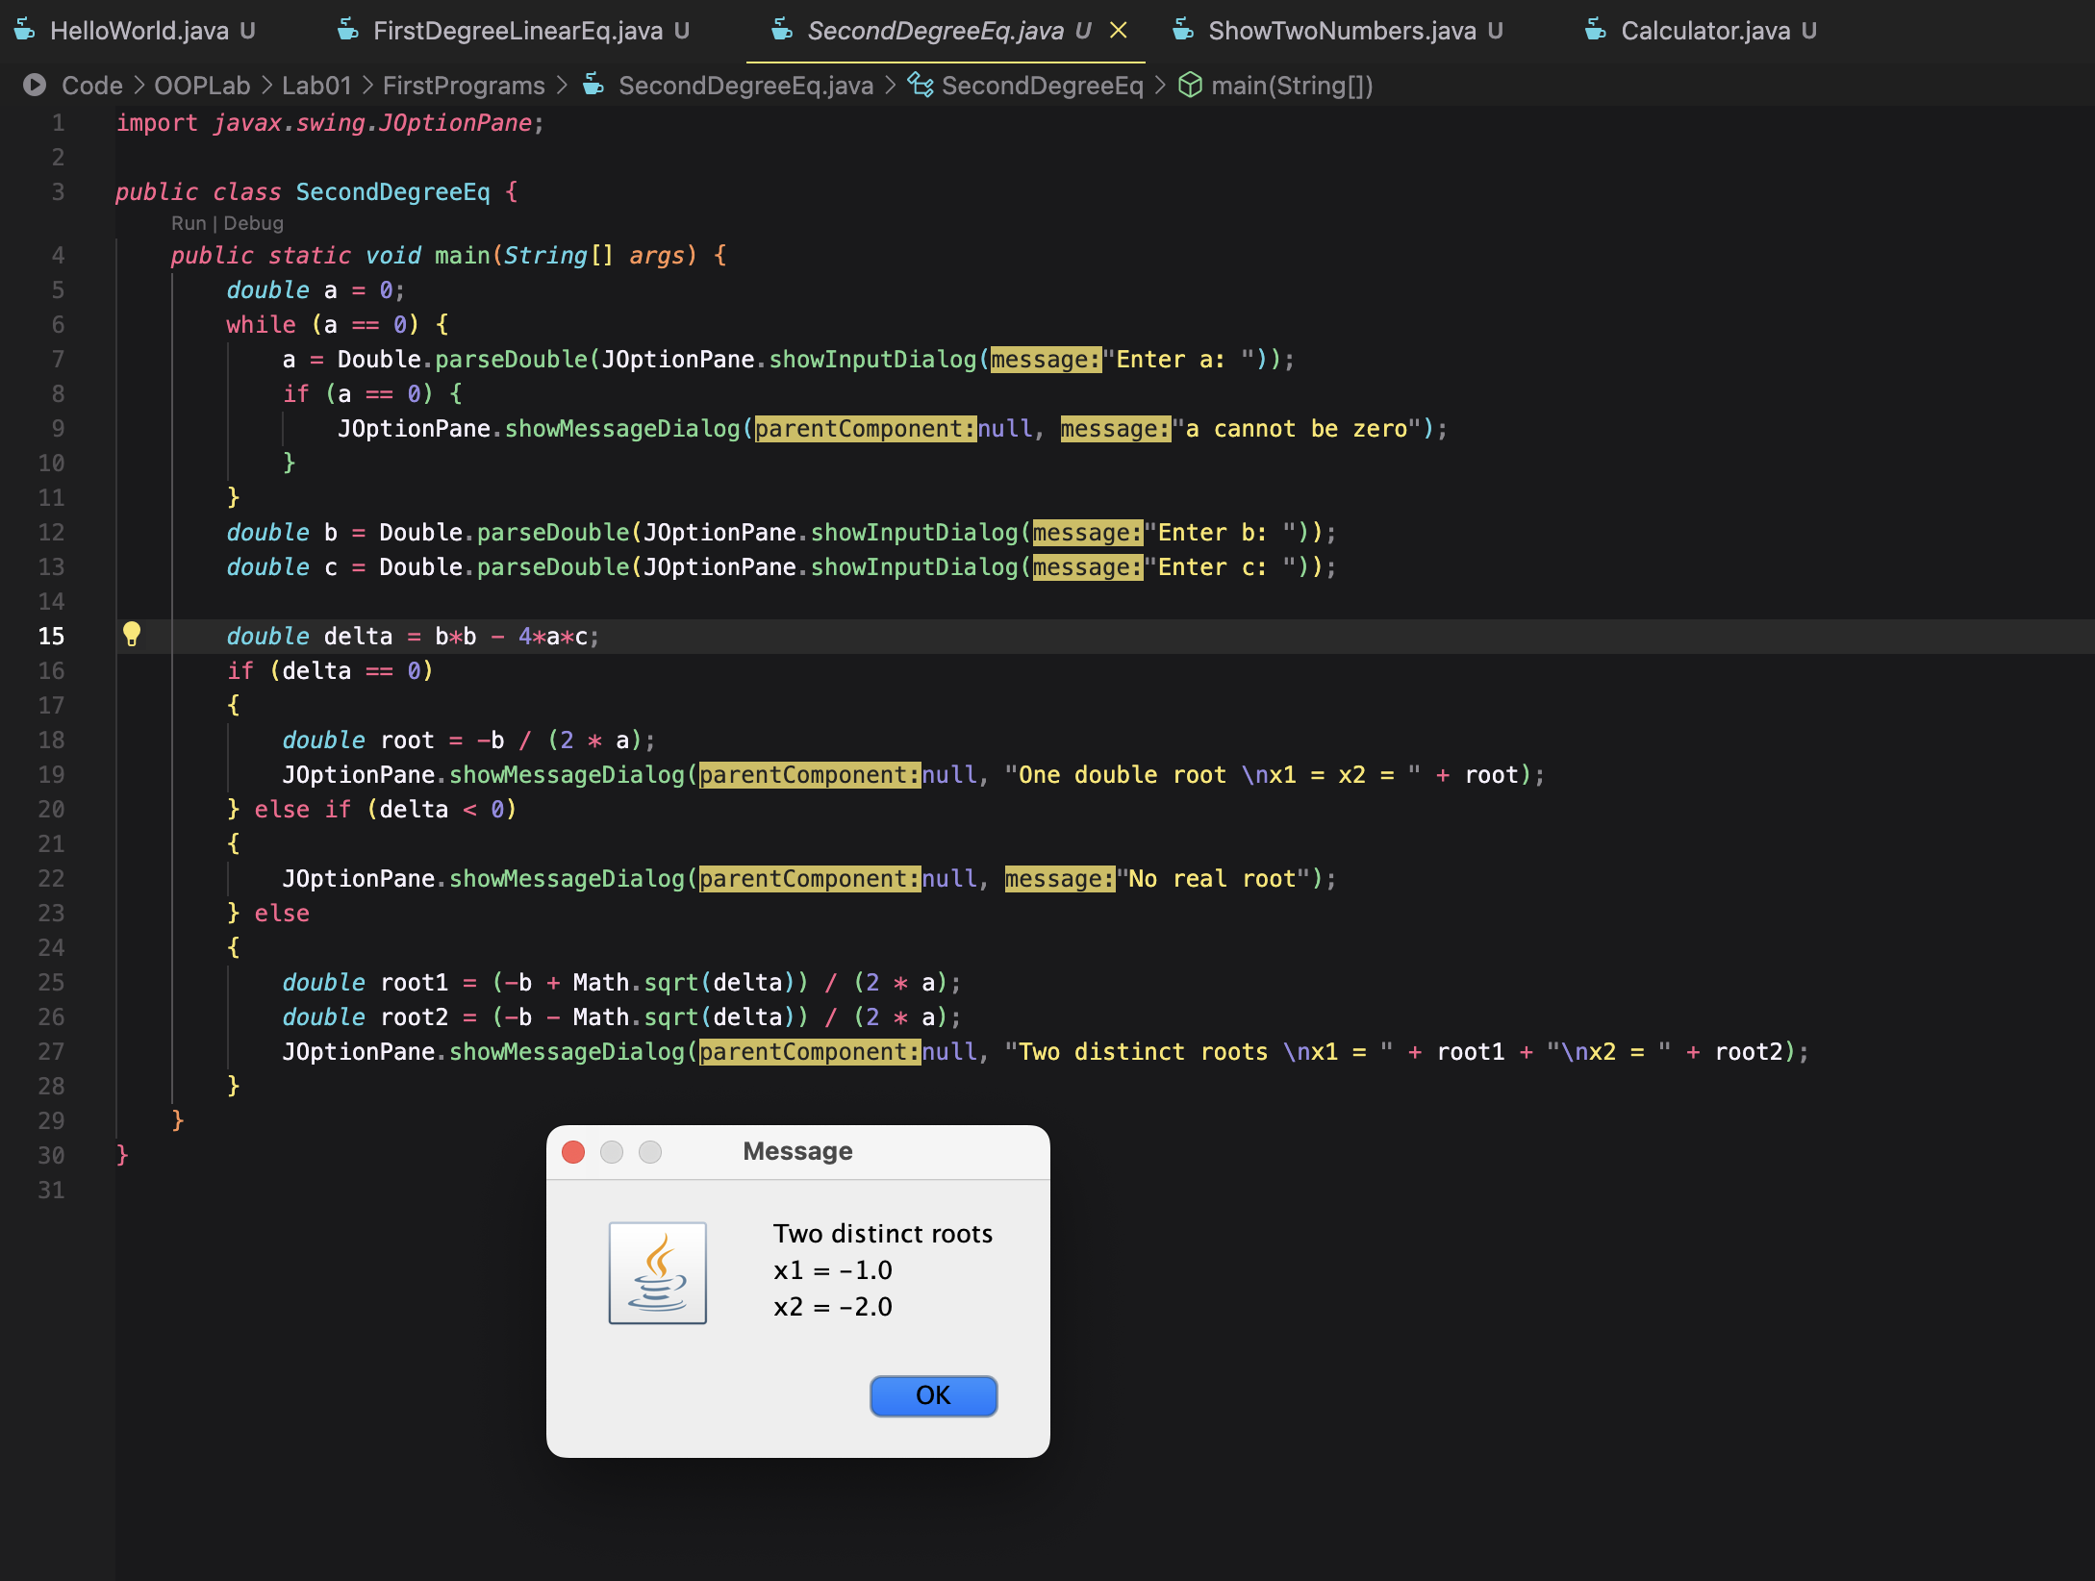

6 Exercises

6.1 Write, compile and run the ChoosingOption program:

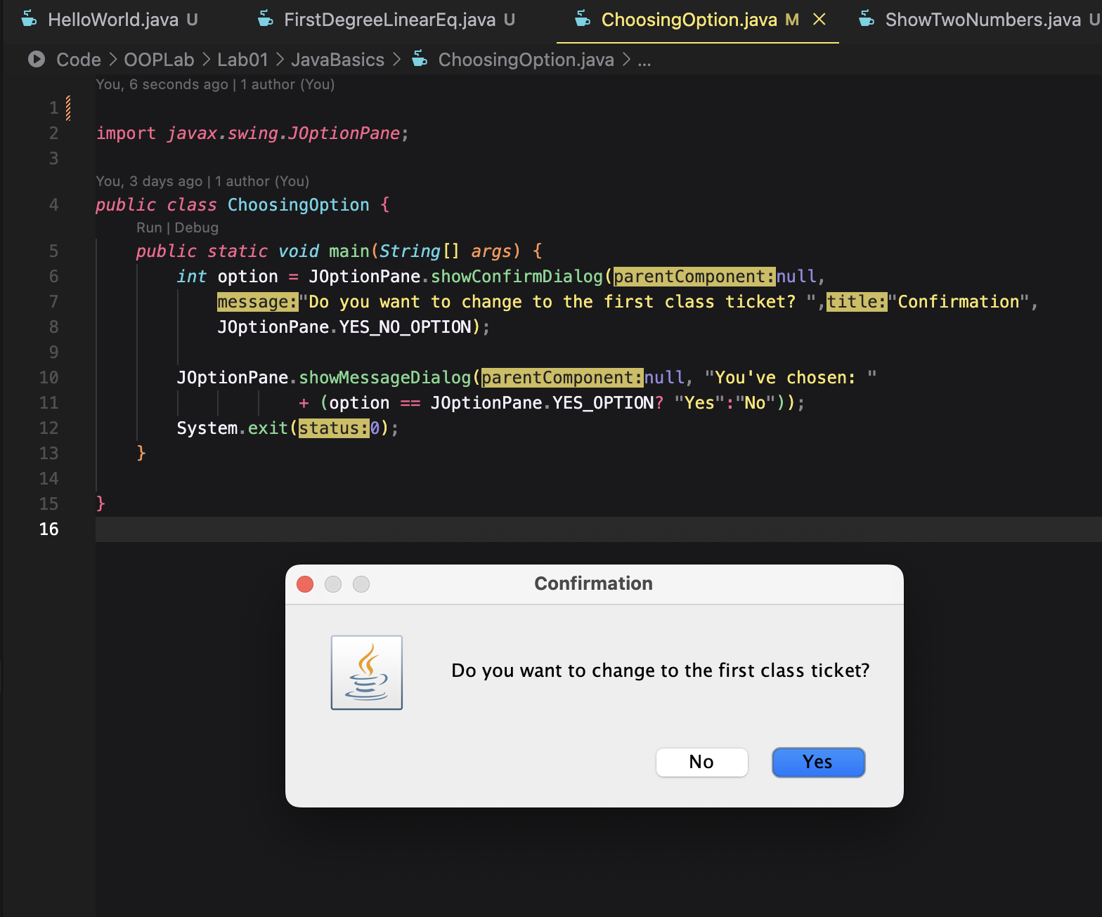

6.2 Write a program for input/output from keyboard

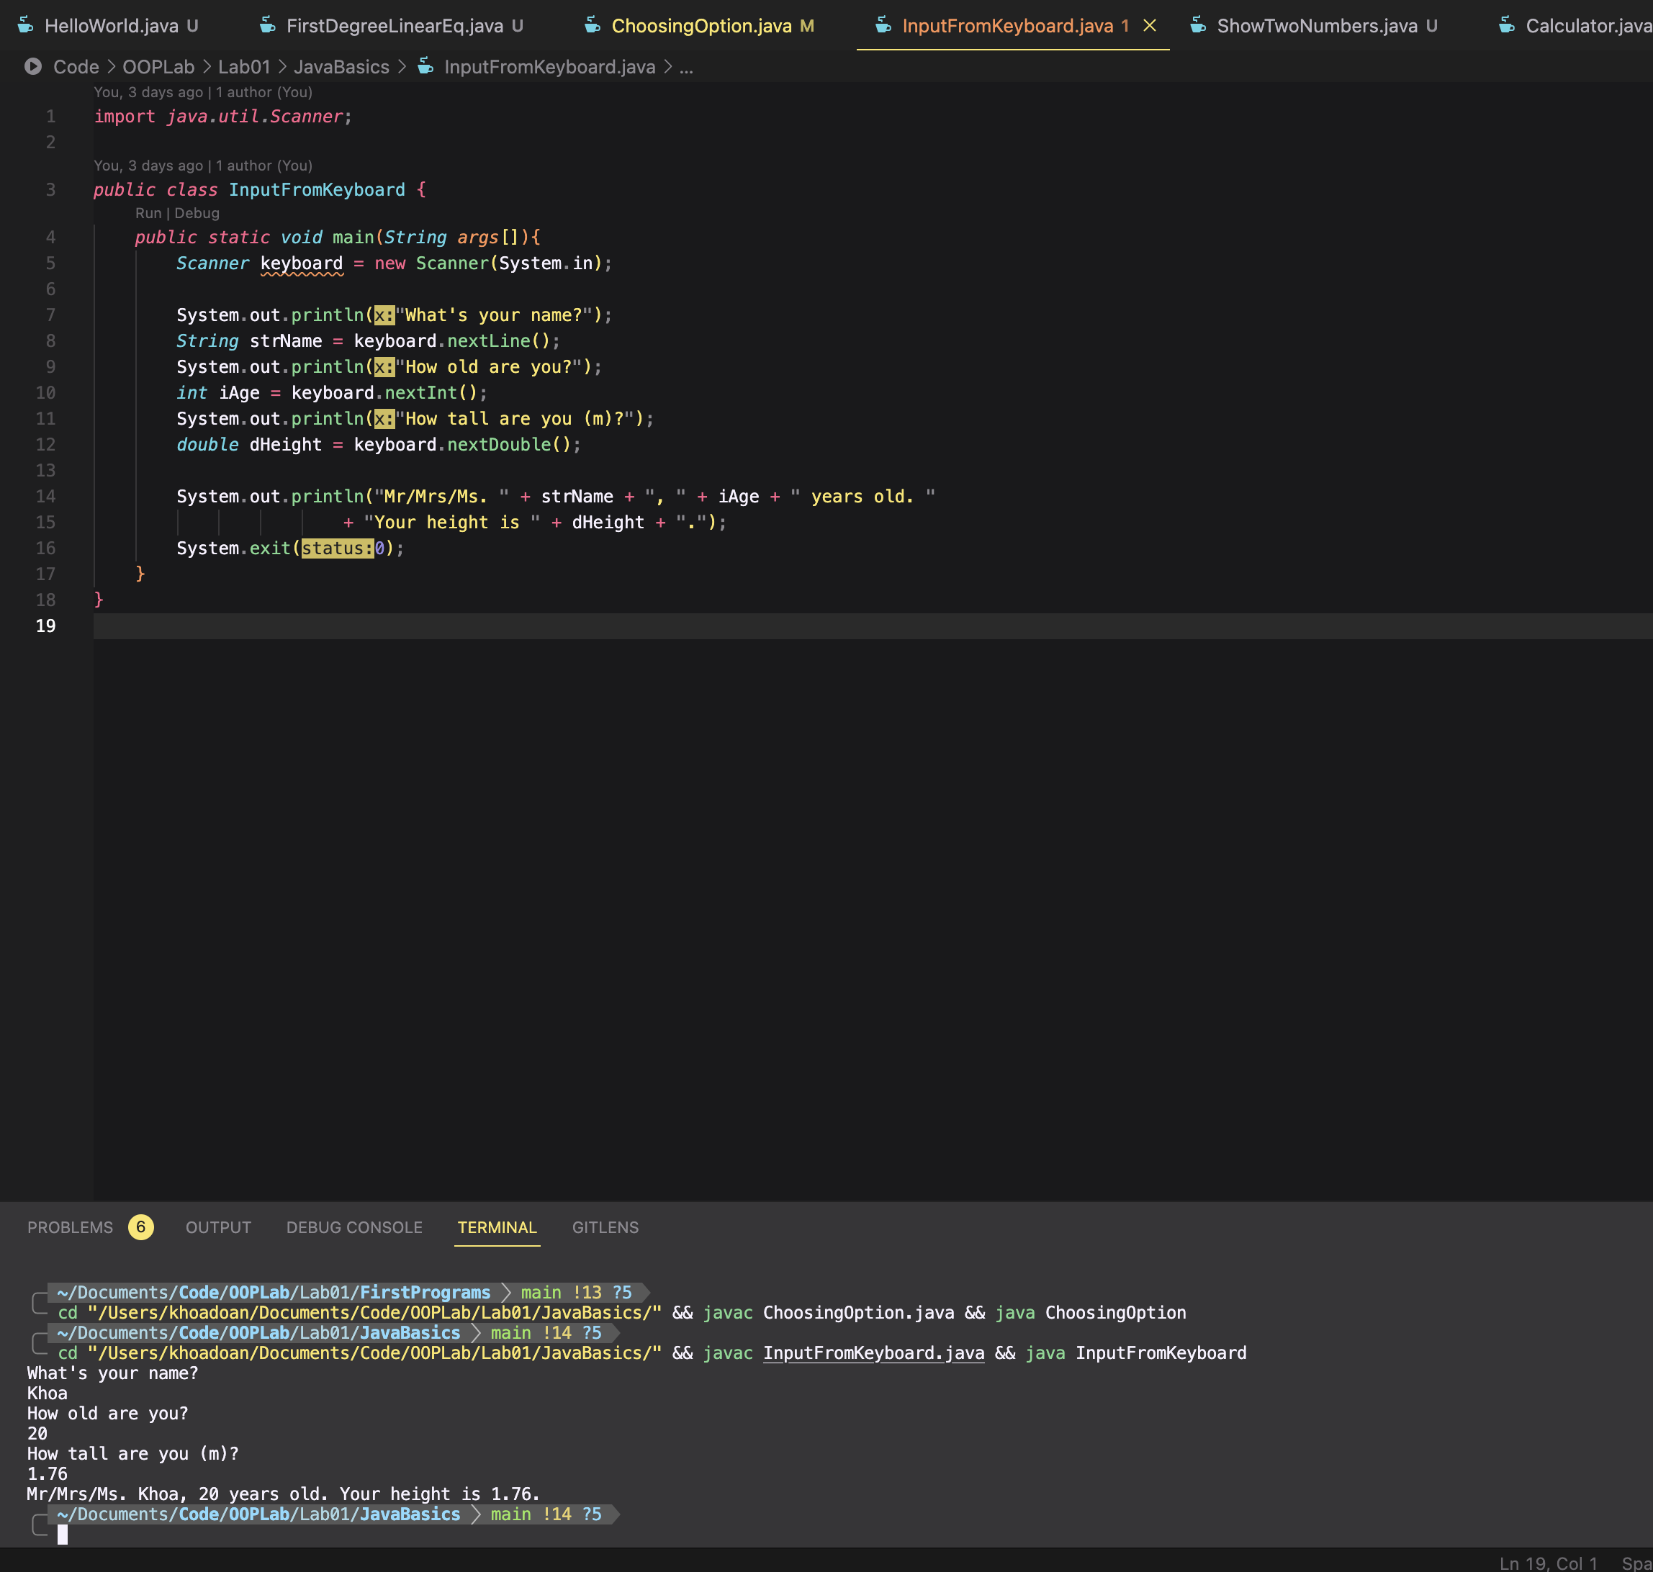

6.3 Write a program to display a triangle with a height of n stars (*), n is entered by users.

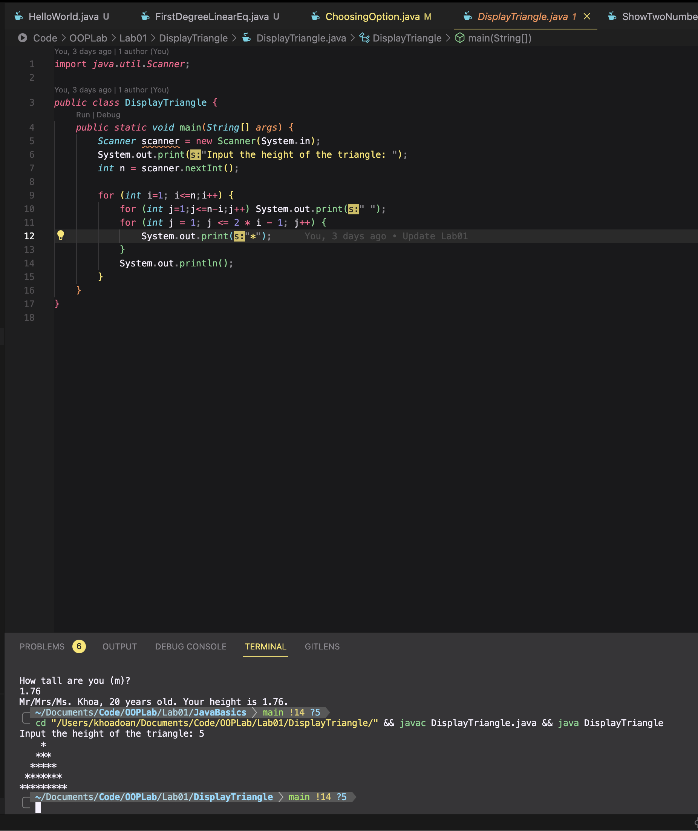

6.4 Write a program to display the number of days of a month, which is entered by users (both month and year). If it is an invalid month/year, ask the user to enter again.

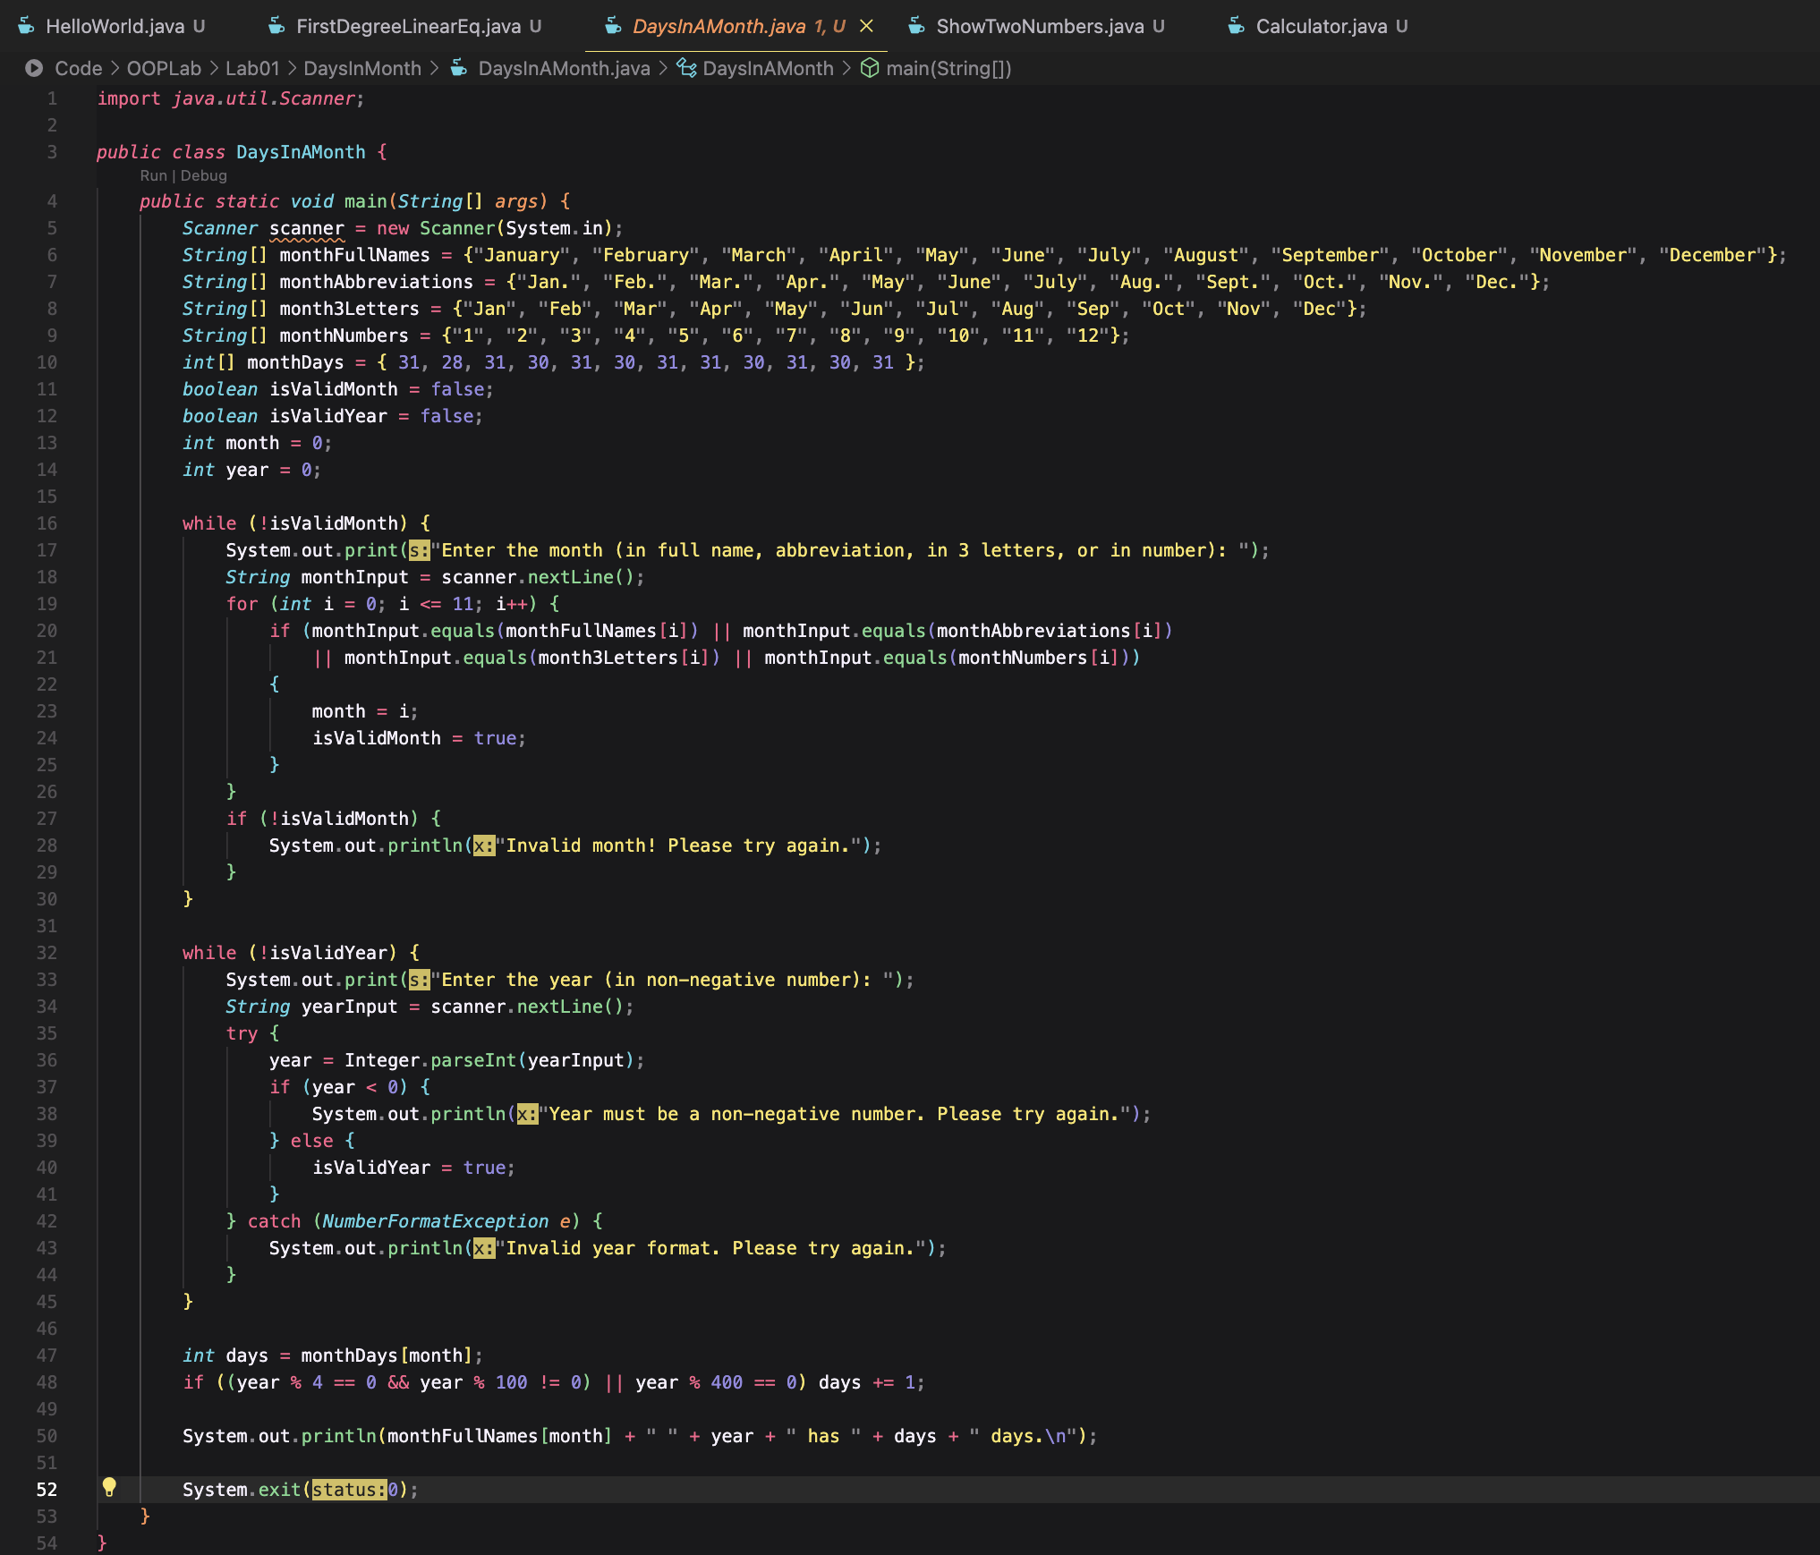



6.5 Write a Java program to sort a numeric array, and calculate the sum and average value of array elements.

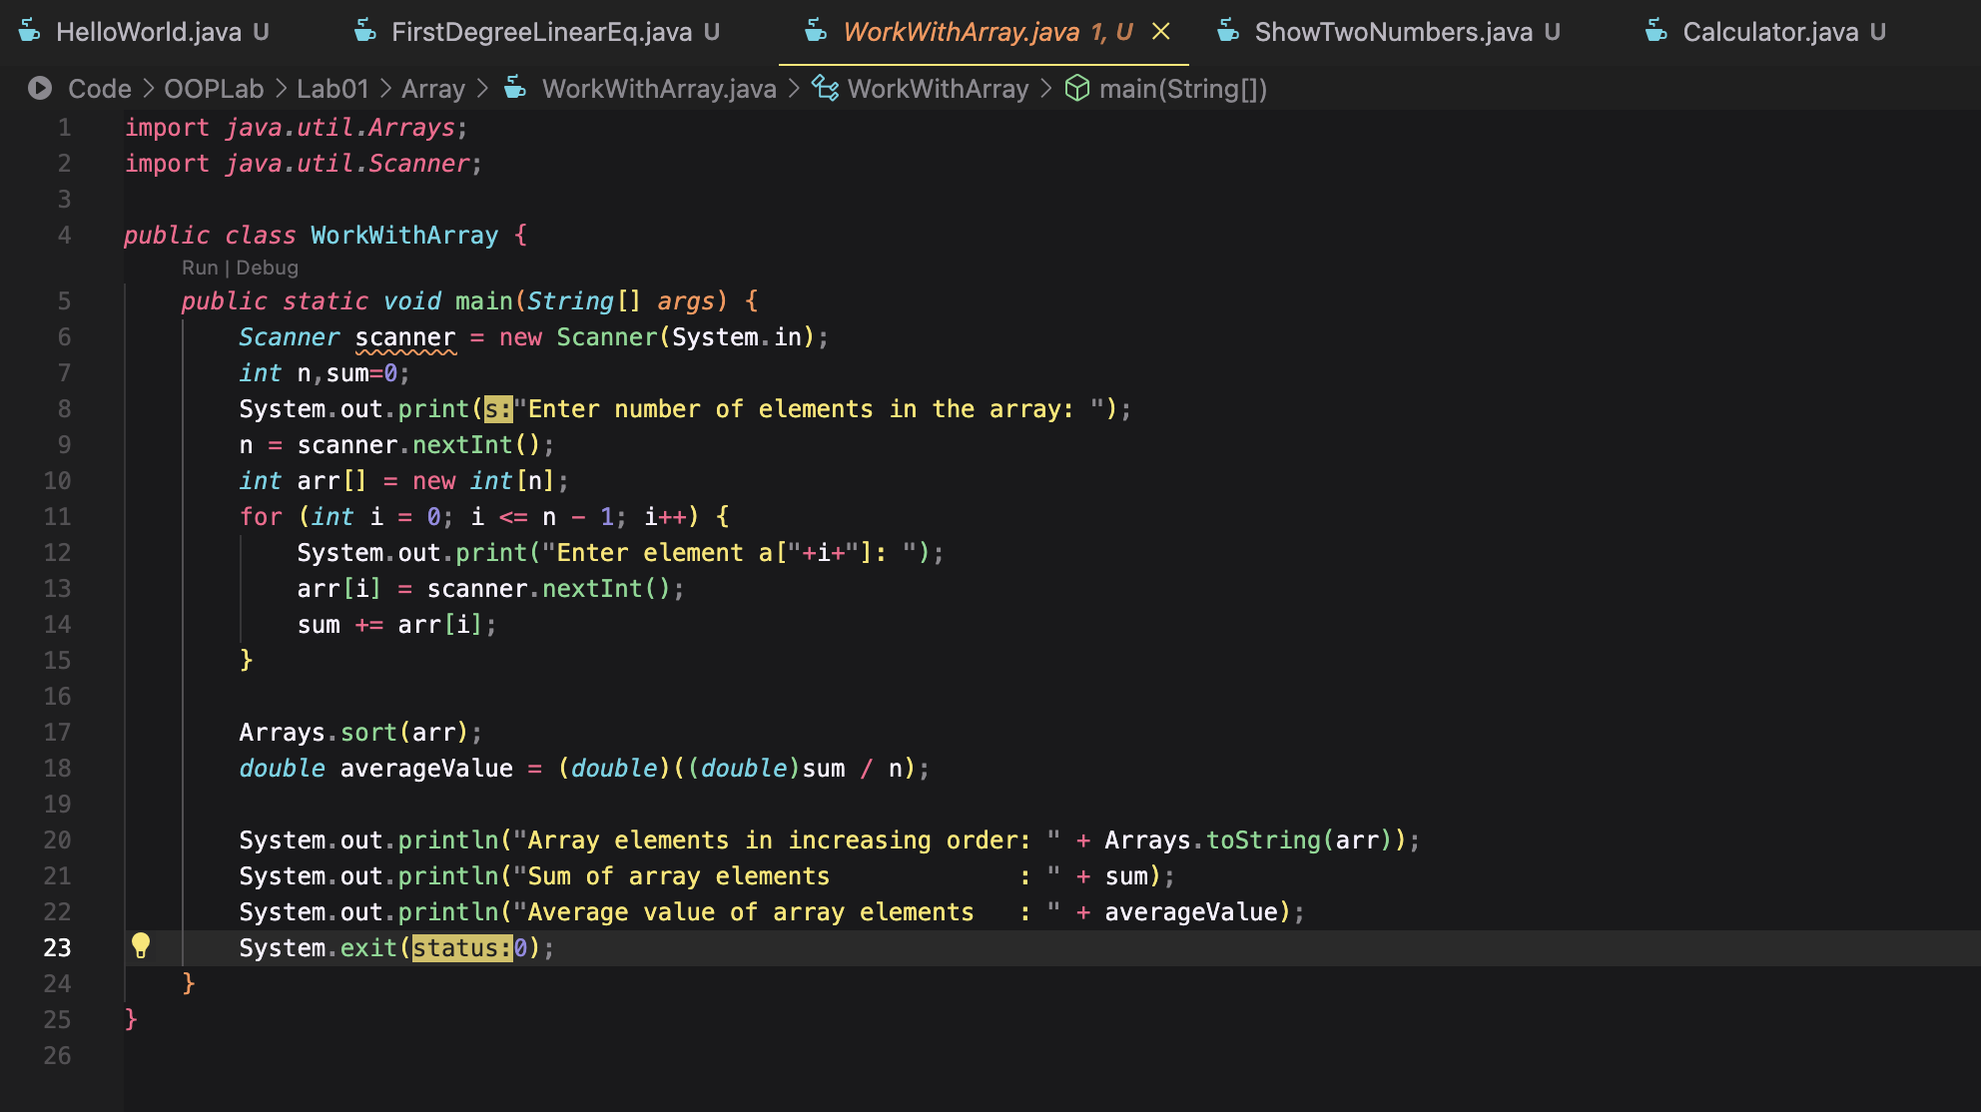

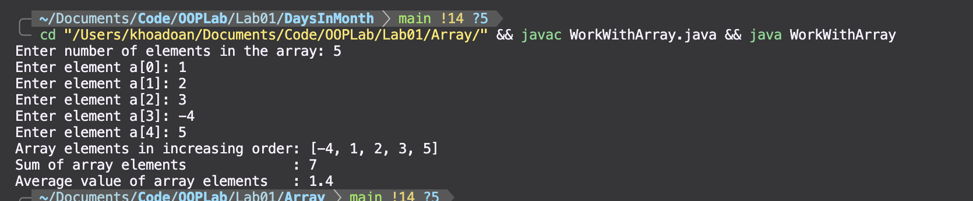

6.6 Write a Java program to add two matrices of the same size.

